

Software Requirements Specification

for

PenSys: Digitalized Informer and Registration System for Senior Citizen

**Version 1.0 approved**

**Prepared by JTR Incorp.**

**JTR Incorp.**

**July 10, 2021**

**Table of Contents**

**Table of Contents ii**

**Revision History ii**

**1. Introduction 1**

1.1 Purpose 1

1.2 Document Conventions 1

1.3 Intended Audience and Reading Suggestions 1

1.4 Project Scope 1

1.5 References 1

**2. Overall Description 2**

2.1 Product Perspective 2

2.2 Product Features 2

2.3 User Classes and Characteristics 2

2.4 Operating Environment 2

2.5 Design and Implementation Constraints 2

2.6 User Documentation 2

2.7 Assumptions and Dependencies 3

**3. System Features 3**

3.1 System Feature 1 3

3.2 System Feature 2 (and so on) 4

**4. External Interface Requirements 4**

4.1 User Interfaces 4

4.2 Hardware Interfaces 4

4.3 Software Interfaces 4

4.4 Communications Interfaces 4

**5. Other Nonfunctional Requirements 5**

5.1 Performance Requirements 5

5.2 Safety Requirements 5

5.3 Security Requirements 5

5.4 Software Quality Attributes 5

**6. Other Requirements 5**

**Appendix A: Glossary 5**

**Appendix B: Analysis Models 6**

**Appendix C: Issues List 6**

**Revision History**

|  |  |  |  |
| --- | --- | --- | --- |
| **Name** | **Date** | **Reason For Changes** | **Version** |
|  |  |  |  |
|  |  |  |  |

# Introduction

PenSys: Digitalized informer and Registration System for Senior Citizen pensioners is a system that specifically planned to help the Senior Citizen to receive information, news and announcements from the OSCA (Office of Senior Citizen Affairs). This system also helps the Senior Citizen to be able to register through online to minimize the inconvenience by registering in their own house instead of traveling to the nearby OSCA in their Municipality, which can be also dangerous for them. This is one of the reasons for the making of this project.

The intended audience of this study is the Senior Citizen Pensioner,it is significant to them because it will help them to know the progress of their pension through notification coming from DWSD. Senior Citizen**,** it is significant because they can conveniently apply to be part of the Social Pension. Researchers, this study provides learning experience that will surely enhance the researcher’s skill that can help them in the future. Future Researchers**,** this study could help them as reference if they were conducting research related to the study.

The 30% range of this system project is that it already has the user module. Our system has two users. The OSCA Personnel and Senior Citizen President. The system already has the login interface for the two users. In OSCA Personnel login interface, it will ask the username and password same as the Senior Citizen President login interface. After logging in, in the OSCA Personnel Account it will direct to the homepage of the OSCA website while in the Senior Citizen President account it will direct to the registration form for senior citizen registrant.

# Overall Description

## Product Perspective

PenSys: Digitalized Informer and Registration System is intended for the Office of the Senior Citizen Affair or OSCA. This system can be to their advantage to be more convenient and reliable when it comes to dissemination of information and registering Senior Citizens of Nasugbu, Batangas in Social Pension.

## Product Features

* Front Page
* OSCA Login
* OSCA Homepage
* OSCA Announcement
* SC President Login
* SC Sample Form

## User Classes and Characteristics

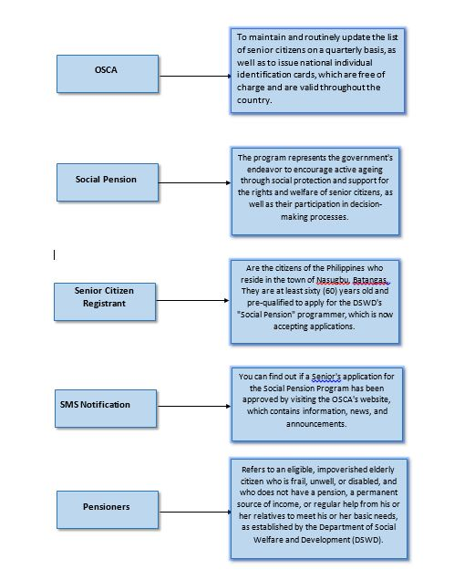

## Operating Environment

The system will require a hardware platform like computer and mobile phones. For the computer, the recommended hardware is at least 2GB of RAM and has a functional keyboard, mouse and monitor. The minimum Operating System for the computer is at least Windows 7. And for the mobile phone, the required specifications is at least 1GB of RAM and the Operating System is Android and also a compatible browser.

## Design and Implementation Constraints

All employees should be eligible to join the pension plan. They study the pension attentively in order to appropriately appraise the payment of pension in their area and how to make the payment of pension more convenient utilizing a computerized system, and for the similarities that this Social Pension has. Both attempted to create a system that is more convenient for retirees, with the exception that our group study primarily focused on information dissemination to retirees and registration features for senior citizens.

***A Mobile Application***

In order to keep track of pension payments In the instance of the Kenyan pensions department, the government's system for distributing pensions to citizens is ineffective, and the process is extremely tough for their beneficiaries. So they came up with the idea of developing a mobile application that would be exclusively for pensioners from the civil service whose pension is provided by the Department of Pensions, and for the similarities between this mobile application and the Design and Implementation of Workers Pension Verification System in Central Region of Nigeria, which both aimed to develop a system that would be more convenient for pensioners from the civil service.

***Web-Based Pension Fund Management System***

In accordance with the system referenced, they must further strengthen their - system in order to eliminate the impediments that are associated with the traditional pension management procedure. This approach will require them to concentrate on web-based applications for the storage of pension funds. Because it is a financial issue, they must correct their system because it is not just a financial problem, but it is also a pension issue for the elderly and those who are most in need. The similarities between this system and others are that both systems use the same technologies and are intended to replace a manual method. The distinctions between this web-based system and others are that this system is focused on handling the pension procedure and fund management.

***Web-Based Pension Fund Management System (In case of Public Servant Social Security Agency)***

It has the same appearance as the Web-Based Pension Fund Management System. In order to streamline these complex processes for the advantage of the agency, the Web-Based Pension Fund Management System was created. This system is intended for individuals who are experiencing difficulty obtaining pension benefits for retirees. As previously stated in the Web-based system, when it is stated that pension involves money and that we should not simply allow someone to destroy this system because many people require a pension, and of course for the similarities it has Both aimed to create an online platform to replace the traditional system, and for the differences about this system based on our study, it shows that it is solely focused on developing a system that will work for everyone.

***Conduent Pension Administration System user Satisfaction***:

Sigma Pensions Abuja is the subject of this case study. In Abuja, the emphasis is on how to minimize expenses while simultaneously increasing profits in a business. The situation in the surprising many did not reach a consensus on Information Systems (IS) not because of the incorrect selection of goods and vendors, but rather because of user discontent with the systems. The CPAS team is looking at the information reception test conducted by the system. According to their research, their CPAS system has been effective because they are able to manage the system smoothly and make it accessible to those in need, as well as because of the commonalities that this system brings about. Both studies are concerned with increasing user satisfaction and providing higher-quality services, with the exception of our study, which is concerned simply with developing a system that aids in the dissemination of information and the facilitation of registration.

## Assumptions and Dependencies

Since this is only 30% of the system only, there are no required dependencies for the development of the system.

# System Features

## Registration Form

3.1.1 Description and Priority

Only Senior Citizen Presidents can access this form.

3.1.2 Stimulus/Response Sequences

3.1.3 Functional Requirements

REQ-1: Mobile Phone /

REQ-2:

## SMS Notification

3.1.1 Description and Priority

Announcements coming from OSCA to Pensioner are more convenient, Only OSCA personnel can access this feature of this system.

3.1.2 Stimulus/Response Sequences

3.1.3 Functional Requirements

REQ-1: Mobile Phone

## Generating of Reports

3.1.1 Description and Priority

The system has a feature of generating reports on each list. List of pensioners and list of registrants.

3.1.2 Stimulus/Response Sequences

* Which barangay
* How many pensioner on each barangay
* How many female and men on each barangay

3.1.3 Functional Requirements

REQ-1: Mobile Phone /

REQ-2:

.

# External Interface Requirements

## User Interfaces

Here are the Sample User Interfaces of the System;

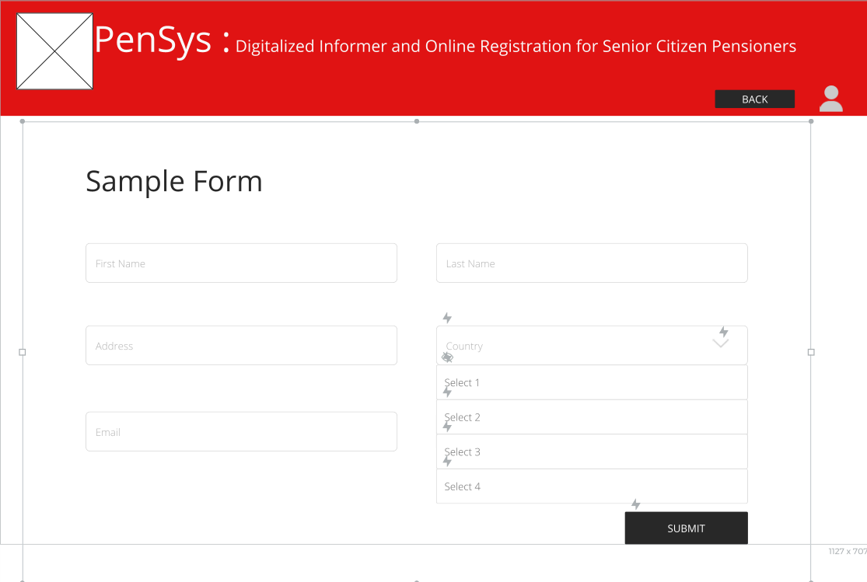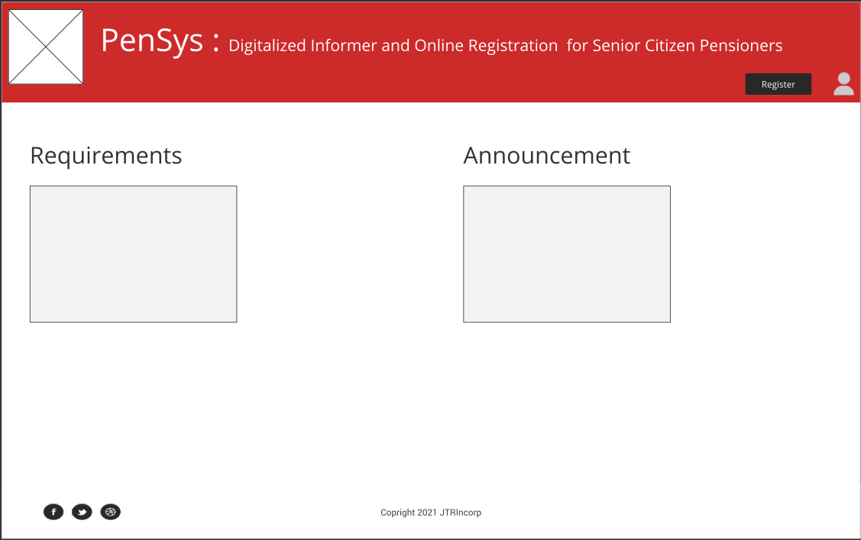

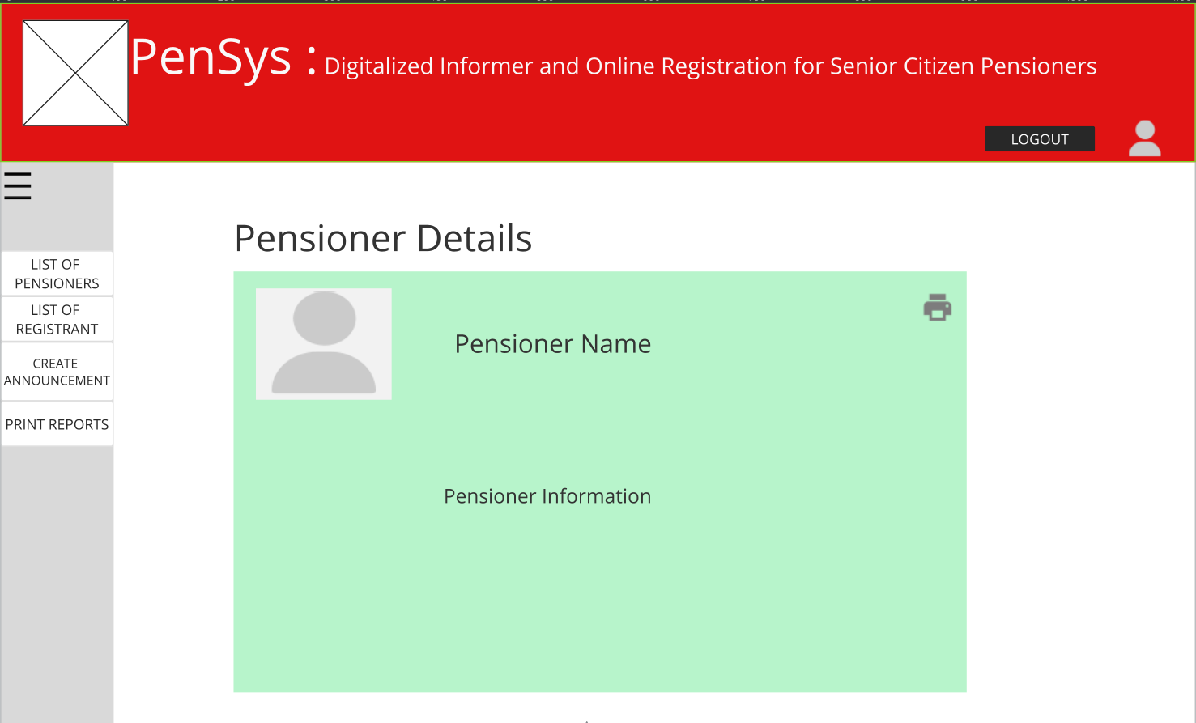

## Hardware Interfaces

This system can be accessed through a computer or a mobile device. These devices will be used as a medium or channel of transmission of data and accessing the system. In addition, they’ll also be a device that will receive announcements like SMS Notifications for the announcements coming from the OSCA Personnel.

## Software Interfaces

The database that will be implemented in this project is Xampp database because it is where the developers are more familiar with. SMS Notification will be also implemented for the notification of announcements from the OSCA Personnel

## Communications Interfaces

HTTPS or Hypertext transfer protocol secure will be used as a protocol because it is more secure than http. Since this project is dealing with sensitive information, the developers decided to choose this protocol to protect the user’s information from leakages or breaches from unauthorized persons.

# Other Nonfunctional Requirements

## Performance Requirements

The system will be tested by two different individuals, first is a technology literate person, who can manage and explore the system without the guidance of the developers or other people, and second is a not technology literate person, who will be guided by the developers. Both of their comments and feedback will be used to improve the system.

## Safety Requirements

OSCA is a very sensitive organization. It is a government organization. Information of each senior citizen pensioner in Nasugbu, Batangas is on their database. For the safety of each information, we made only two accounts that can access the system. Two usernames and two passwords.

## Security Requirements

To access the system, need to identify the username and password of which account you are going to use. The system will use HTTPS to secure the connection between the web browser and website. All data that will be stored in the database will be encrypted to prevent leakage and breaches. All users will undergo a user acceptance to prevent the misuse, modification, deletion, or exploitation of information that will be involved in this system.

## Software Quality Attributes

Attributes that will be important for both developers and users are adaptability, availability, correctness, flexibility, maintainability, portability, reliability, reusability, robustness, testability, and usability. These attributes will help the developers in developing the system, while making the user trust the system.

**Appendix A: Glossary**

***User -*** *pertains to OSCA personnel that will disseminate the information and Senior Citizen that will apply for the Social Pension.*

***Social Pension-*** *Social Pension Program is a monthly financial assistance by the government for the indigent senior citizen.*

***Pensioner-*** *refers to the recipient of the monthly financial assistance residing in Nasugbu.*

***Senior Citizen Registrant –*** *are the citizens residing in Nasugbu, Batangas. They are aged sixty (60) above, pre-qualified to be applicants of the project of DSWD called “Social Pension”.*

***SMS Notification -*** *information, news and announcements from the OSCA*

***OSCA-*** *Office of Senior Citizen Affairs*